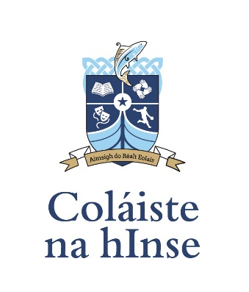

Code of Behaviour – February 2022

Vision
‘Our vision for Coláiste na hInse is an outstanding progressive centre of teaching and learning, where the three cornerstones of our school bród (pride), uaillmhian (ambition) and dearfacht (positivity) are lived daily allowing personal growth and wellbeing and empowering us to aimsigh ar realt eolais through positive relationships, respect, inclusivity and encouragement'.

CONTENTS

- RATIONALE
- RELATION TO VISION
- AIMS OF OUR CODE OF POSITIVE BEHAVIOUR
- CONTENTS
  - Section 1: Positive Behaviour Matrix
  - Section 2: How Positive Behaviour is promoted
  - Section 3: Responsibilities of Positive Behaviour Expectations
  - Section 4: Sanctions and Interventions for Breaches of Positive Behaviour Expectations
  - Section 5: Restorative Practice

- ROLES AND RESPONSIBILIITES
- REVIEW AND EVALUATION

- Rationale
Coláiste na hInse aspires to be an outstanding and progressive centre of teaching and learning. This is possible where all members of the school community are clear in relation to the positive behavioural expectations required of them. When these expectations are met, a learning environment and culture characterised by respect, dearfacht (positivity), uaillmhian (ambition) and bród (pride) is created. To support this learning environment and culture this Code of Positive Behaviour has been drawn up and is set out below.

- Relation to Vision
To realise our vision for Coláiste na hInse, all members of the school community must be very clear on the positive behaviour expectations required of them, how these expectations are promoted and encouraged and of the consequences that must occur when these expectations are not met. Good order is required for all members of our Clann to experience personal growth and wellbeing and to be empowered to aimsigh ar realt eolais (reach for our star) through positive relationships, respect, inclusivity and encouragement.

- Aims of our Code of Positive Behaviour

- To outline clearly the positive behaviour expectations required from daltaí (students) while engaging in school activities.
- To outline clearly the ways in which the school promotes positive behaviour, mutual respect and pride in one’s self and in Coláiste na hInse.
- To outline clearly the sanctions that will be employed if positive behaviour expectations are not met.
- To outline clearly the continuum of interventions that will be employed where positive behaviour expectations continue be breached.
- To outline the Restorative Practice (RP) approach encouraged by Coláiste na hInse, when dealing with breaches of the school’s Code of Positive Behaviour.

- Contents

  - Positive Behaviour Matrix
The rationale for adopting a ‘Positive Behaviour Matrix’ approach to behaviour management in our school is to place emphasis on the behaviours that the school community wants to see as opposed to placing emphasis on the behaviours that the school community does not want to see. Behavioural expectations for five different areas of the school are outlined in the matrix below.

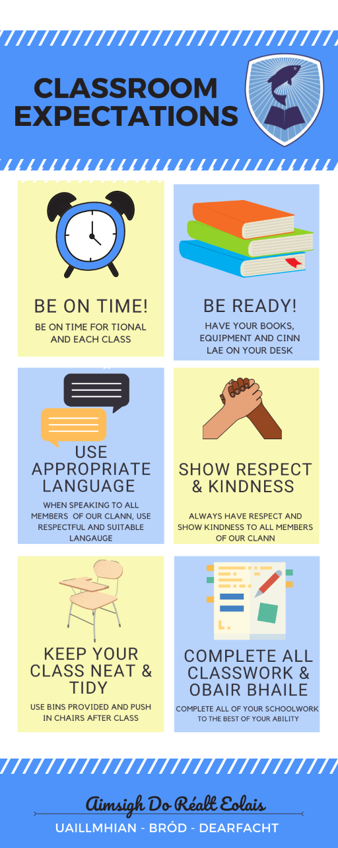

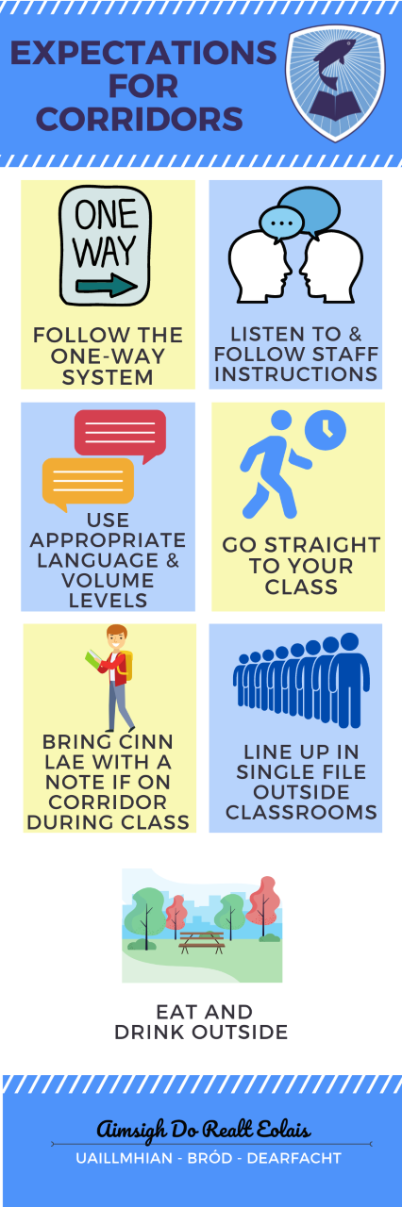
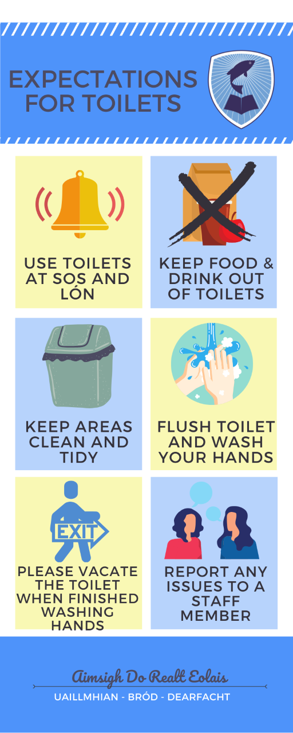
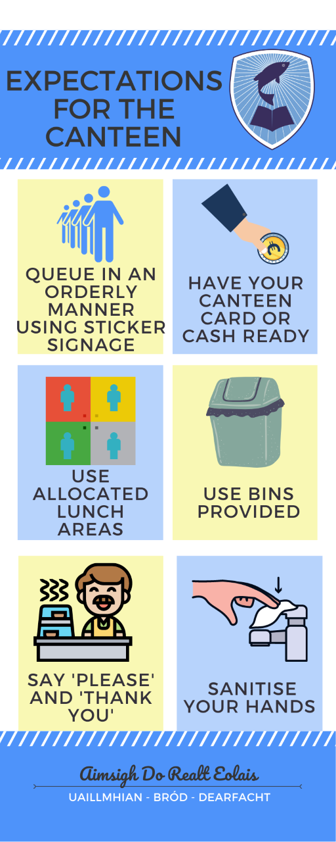
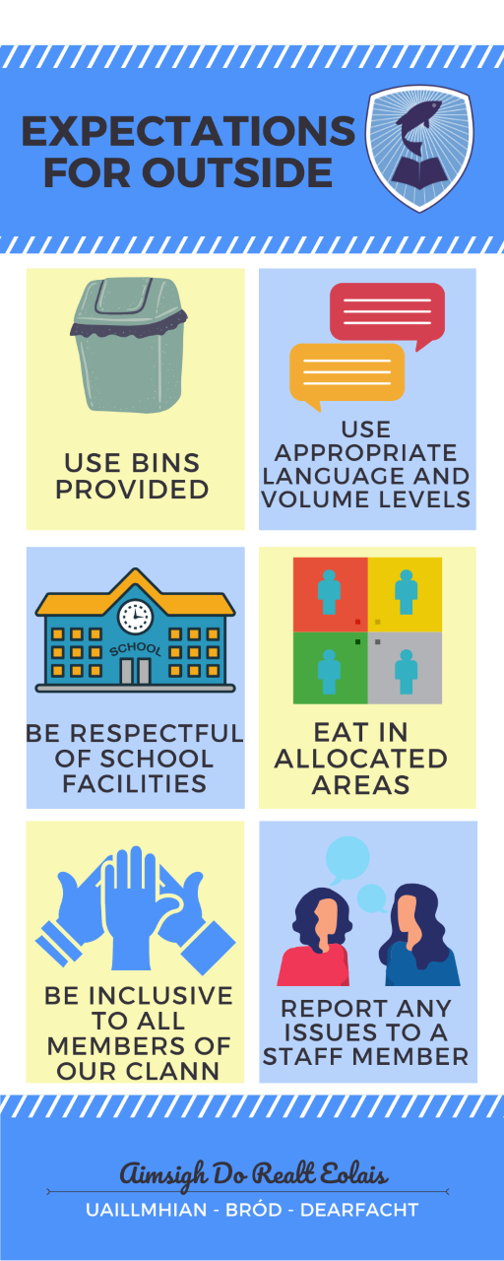
  - How Positive Behaviour is promoted in Coláiste na hInse
In Coláiste na hInse the school operates a ‘Dearfacht programme’ – positivity programme. This programme aims to ‘catch students being good’ and rewards students for meeting and indeed exceeding expectations. The dearfacht programme includes:

- 1-1 meetings with daltaí
- Guidance and counselling support
- Positive behaviour support card
- Extra-curricular activities
- Tionól
- Pastoral relationships between staff and daltaí
- Verbal praise for daltaí in private/in class/at assembly
- Notaí maithe (positive notes) in their Cinn Lae
- Stamps / Stickers in their Cinn Lae
- Teastas Molta (certificate of merit)
- Positive phone call home to parents
- Positive Postcard posted to parents/guardians
- Display of students work in classrooms and on corridors
- Small prizes throughout the year
- Realta na Míosa Awards – held on the last Wednesday of each month
- Gradam Tinrimh (full monthly attendance award)
- Lá dearfacht trips away for daltaí
- Leadership Roles given to students
- Gradam an Choláiste - Prize giving ceremony in May every year. Awards for academics, attendance, good behaviour, hard work, citizenship, sporting and cultural activities are presented
- Names of award-winning students are displayed around the school
- Promotion of student effort and achievements on school’s social media platforms.

  - Responsibilities of Positive Behaviour Expectations
Positive Expectation | Responsibilities of Expectations
To attend school each day | - Daltaí are expected to attend school each day.  - When a dalta is returning from an absence a note of explanation should be written by parent/guardian.  - Daltaí must stay on the school campus at all times during the school day. If leaving early a note of explanation must be given (present to Caomhnóir) and the dalta must be signed out (if under 18) by a parent/guardian or nominated adult. If a dalta returns later (e.g. after an appointment) they must sign back in at the oifig.  - Daltaí (over 18) must contact a Deputy Principal the Principal before signing themselves out.
Be on time | - Daltaí are expected arrive at school with enough time to prepare for class before tionól and to be on time for all classes during the day. Supervision is in place from 8.30AM each morning.  - If a dalta is unavoidably late, the reason should be recorded in the dalta’s cinn lae by his/her parent or guardian. Daltaí who are late must sign in at the oifig.
Be prepared for school and for all your classes | - Daltaí must wear correct school uniform each day to school (see website for code of dress)  - Daltaí are expected to visit their taiscedán (locker) before school, during sos, lón and at the end of the school day.  - Daltaí are expected to have all their books, equipment and cinn lae ready for each class. Cinn lae must be placed on desk.
Complete all classwork and obair bhaile | - Daltaí should complete all classwork and obair bhaile to the best of their ability.  - Daltaí must respect the right for others in their rang group to learn and for their múinteoir to teach. Behaviours that disrupt teaching and learning are not permitted.
Use appropriate language | - Daltaí must always use appropriate language while in school and when representing the school on outings/activities. The use of bad language is disrespectful and will not be accepted.
Show kindness and respect | - Daltaí must show kindness and respect to all members of our Clann. Aggressive language or acts will not be accepted.  - Bullying of any kind is unacceptable – please also see anti-bullying policy (on school website).  - Breaking, hiding or stealing another person’s property is not acceptable.
Keep the school environment neat and tidy | - Daltaí are expected to clear up after themselves in all areas of the Coláiste e.g. at the end of class, in the bathrooms, in the canteen and in outside lunch areas.  - Litter bins are provided in all areas and should be used.  - Chewing gum is not permitted.  - Daltaí are expected to be respectful of school property. Graffiti or other forms of vandalism are unacceptable.  - Breaking or stealing school property is unacceptable.  - Damaging or interfering with school safety equipment is unacceptable.
Be responsible for your own possessions | - Daltaí are responsible for looking after their own possessions. Their school taiscedán should be kept locked while not in use.  - If daltaí cycle to school, please use bike racks provided and lock bicycles to ensure safe keeping.
Be responsible for your own health | - The possession, use of drugs or alcohol while in school or while engaged in school activities is strictly forbidden (please see substance use policy).  - The sale of drugs or alcohol while in school or engaged in school activities is strictly forbidden and will be severely sanctioned and reported to relevant authorities.  - Smoking or the use of electronic cigarettes is strictly forbidden.  - The use of tippex bottles, aerosols, permanent markers and lasers are forbidden.
Be responsible for the safety of yourself and others | - The use of mobile phones is strictly forbidden while at school or on school related activities.  - Physical altercations between daltaí are unacceptable.  - The possession of any weapon or items made or modified to act as weapons are strictly forbidden.

4.4 Sanctions and Interventions for Breaches of Positive Behaviour Expectations

Coláiste na hInse uses a ‘ladder of referral’ system. In the main breaches of the school’s code of behaviour are dealt with using this system. However, on occasion incidents can occur that must be referred directly to a Reáltóir (Year head), Deputy Principal or Principal.

Stage 1
The subject teacher

Subject teachers may use any or all of the following sanctions/interventions (please note this list is not exhaustive)

- Stand near the dalta’s desk
- Redirect to task
- Ask a question and praise if possible – notaí maithe
- Catch being good – praise appropriately
- Verbal warning
- Warn that they will be reseated
- Change of seat
- Bad note in cinn lae (which must be signed by parent/guardian)
- Private conversation after class
- Teacher rang feabhais
- Subject specific corrective worksheet
- Phone call home (sometimes)
- Referral to Réaltóir using Cárta comhrá

Stage 2
The Réaltóir (Year Head)

- Réaltóir to investigate, gather data, keep records
- Phone call home (sometimes)
- Targeted Positive Behaviour support card
- Friday/Saturday Rang Feabhais
- Work with múinteoir and dalta to repair relationship (close circle)
- Referral to Deputy Principal or Principal – Cárta Comhrá
Stage 3
Deputy Principal and/or Principal

The Deputy Principal or Principal may use any of the above sanction or interventions plus those listed below:

- Saturday Rang Feabhais
- External suspension
- Principal/Deputy Principal may refer the student to an outside agency for assistance in behaviour management e.g. LAR
- Principal/Deputy Principal may refer the student to the school guidance counsellor and or NEPS psychologist for assistance in behaviour management.
- Principal/Deputy Principal may refer the student to relevant authorities, including the Gardaí.

EXCLUSION

In order to maintain good order and discipline and ensure the safety of all the students in the school it may be necessary to permanently exclude a student from the school.
Where the Principal considers that the safety of other members of the school community is at risk or where the teaching and learning of other students is being seriously disrupted by a student then he/she will refer this matter to the Board of Management.
The rules of natural justice shall be adhered to and students (over 18) and parents/guardians will be given an opportunity to respond in their own defence prior to any decision being made.
Where the Board is of the opinion that the student should be excluded it shall notify the TUSLA, in writing, of the reasons for this decision.
Parents / Guardians may appeal the decision of the Board to Louth Meath Education & Training Board (LMETB).

Should the LMETB uphold the decision of the Board to exclude a pupil then parents may appeal this decision to the Secretary General of the Department of Education and Science.

(Note: Coláiste na hInse’s Suspensions and Expulsions Policy will be followed in relation to all external suspensions and for Exclusions (see website)

4.5 Restorative Practice

Coláiste na hInse encourages a Restorative Practice approach. Restorative practice is a whole school approach that encourages behaviour that is supportive and respectful. Restorative practice (RP) puts the onus on individuals to be truly accountable for their behaviour and to repair any harm caused to others as a result of their actions. School communities are busy places where from time to time difficulties arise between daltaí and between daltaí and múinteoirí. Restorative Practice asks members of the school community to think about what is causing the difficulty, find strategies to help prevent reoccurrence and to find ways of repairing any damage done to the relationship as a result. In Coláiste na hInse restorative meetings are held (always following an external suspension) during which the following questions are discussed.

What happened?
What were you thinking at the time?
What have you thought about it since?
What has been affected and in what way?
How could things have been done differently?
What do you think needs to happen next?

- Roles and Responsibilities

- The Board of Management will approve the policy and ensure its development and evaluation.
- The Principal will be responsible for dissemination of the policy.
- The school’s Code of Behaviour will form part of the induction programme for all new teaching staff and all PME student teachers.
- It is the responsibility of all teaching staff and PME student teachers to read this code of behaviour carefully.
- It is the responsibility of all daltaí and parents/guardians to read this code of behaviour carefully. Agreement to abide by this code of behaviour is a pre-requisite to admission to Coláiste na hInse.

- Review and Evaluation
The effectiveness of this code of behaviour will be monitored by the Board of Management, Principal, Deputy Principals, teaching and other school staff and Parent’s Association. This policy will be reviewed every two years or as needs dictate during the academic year.

Dates of Consultation:

Staff: 19th January 2022
Parents: 5th April 2022
Student Council: 4th April 2022
Board of Management: 24th May 2022

Ratification of Policy:
This policy was ratified by the Board of Management on: _______________________

Signed: _________________________________ Date: ___________________
(Chairperson of Board of Management)
Signed: _________________________________ Date: ___________________
(Principal – Secretary to the Board)

